**10. Centralized Dashboards for GuardDuty Findings**

* In this architecture, the Guard Duty findings from all the AWS Accounts will be sent to the Central AWS account.

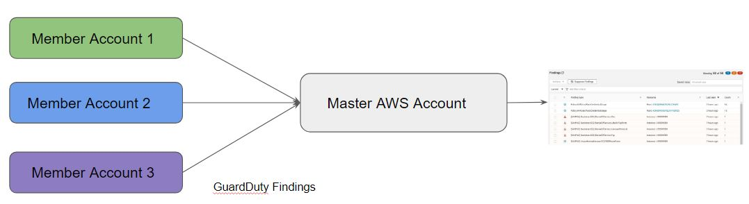

* enabling guard duty across all the accounts that you might have in your organization is recommending. once you enable guard duty across all, then you will have to check findings individually in these accounts and this is quite troublesome.
* in order to have a better architecture, what you need is you need a centralized place where the
* guard duty findings can be stored.
* So, a central architecture is something that is recommended that you have multiple aws accounts.

--- **Steps**

* Click on account in master aws account, by doing this you can able to add member accounts.
* Go to member aws account and accept the request form master account
* Go to finding sections and you will find the findings form master account and member account as well.

**Master account (Add member account to master aws account)**

* we have member accounts and master aws account. the account with all the findings is shared is called as the master aws account or just master account and all the accounts which would be sharing the guard duty findings are called as the member account.
* you have the concept of member account and you have the concept of master account.
* The integration of member to master code is being built with guard duty. So, with few clicks of button, you will be able to do that.

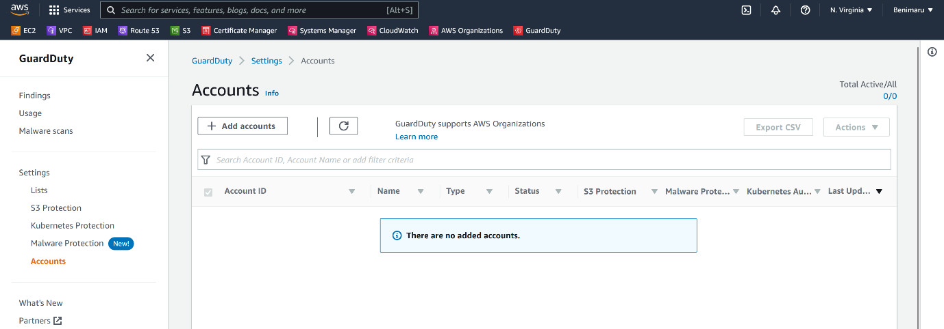

--- click on add accounts.

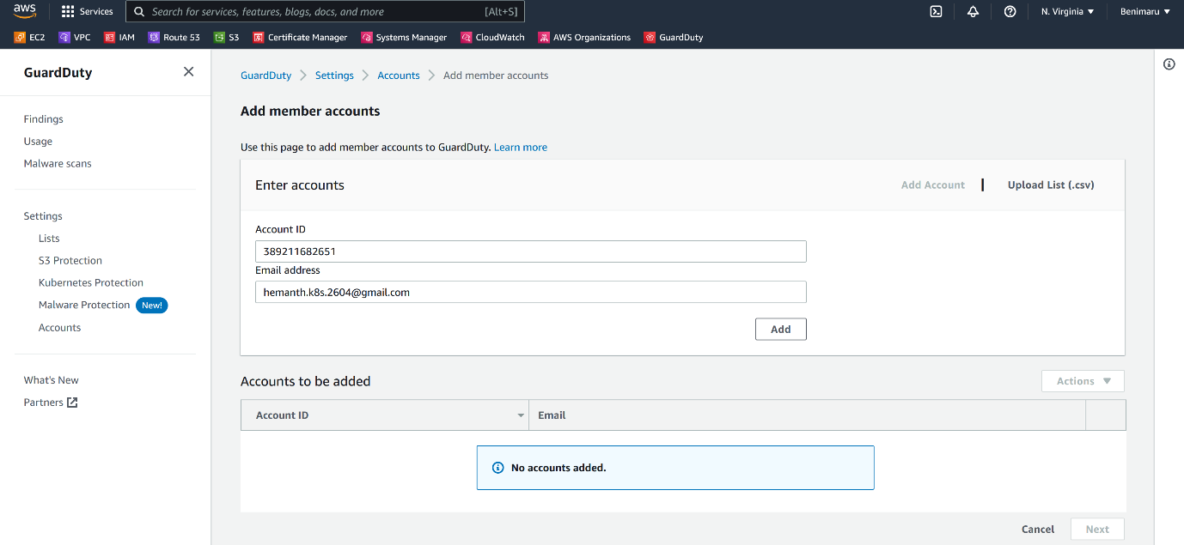

--- here give the member account details and click on add.

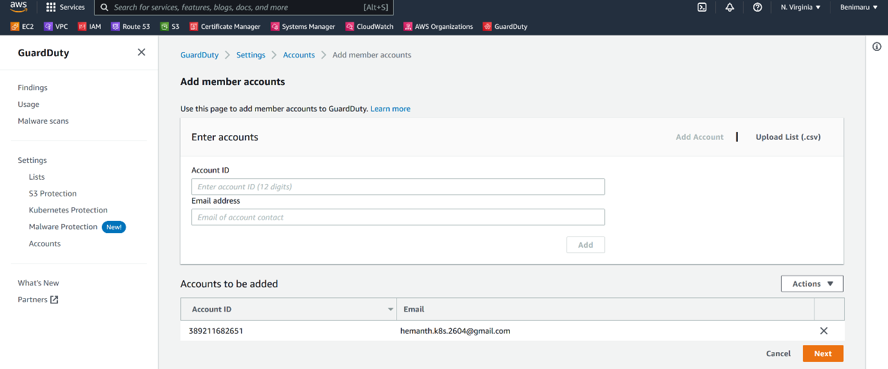

--- member account is added, click on next.

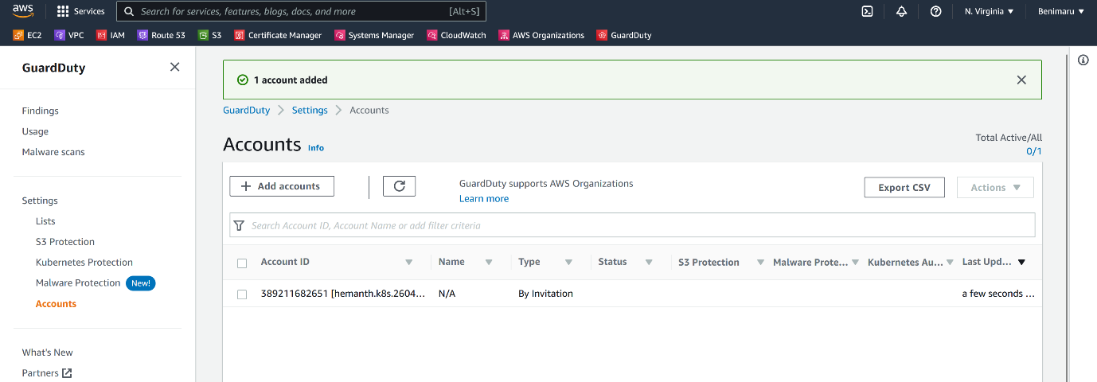

--- now it states that one account is added. Invite the account.

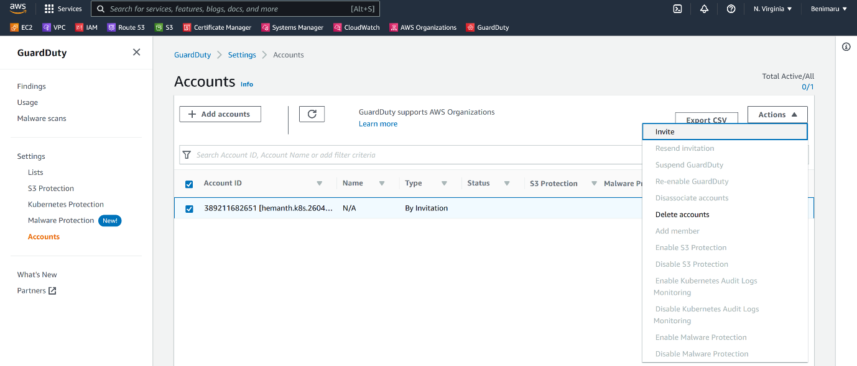

--- click on invite.

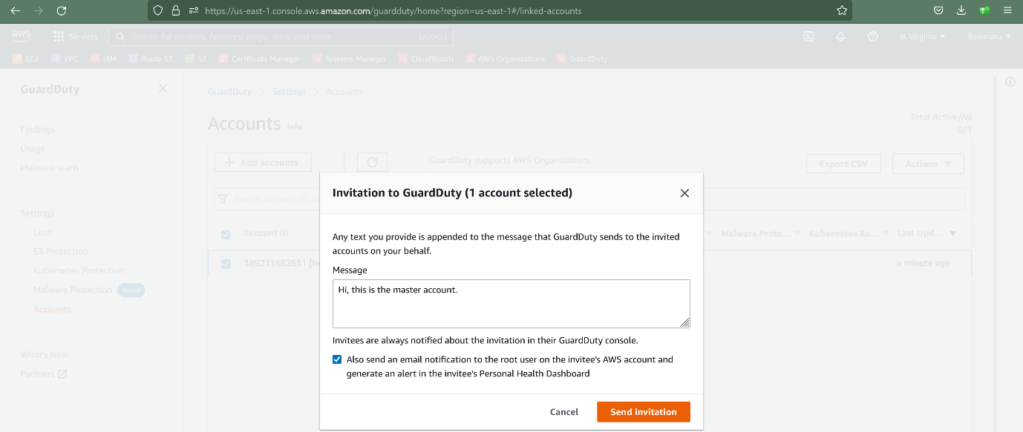

--- click on send invitation.

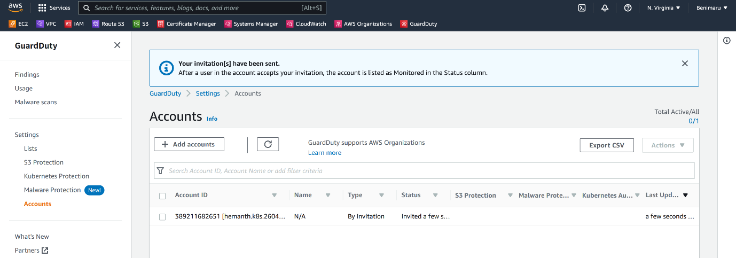

--- the invitation has been sent

--- **note** – go to the member account and accept it.

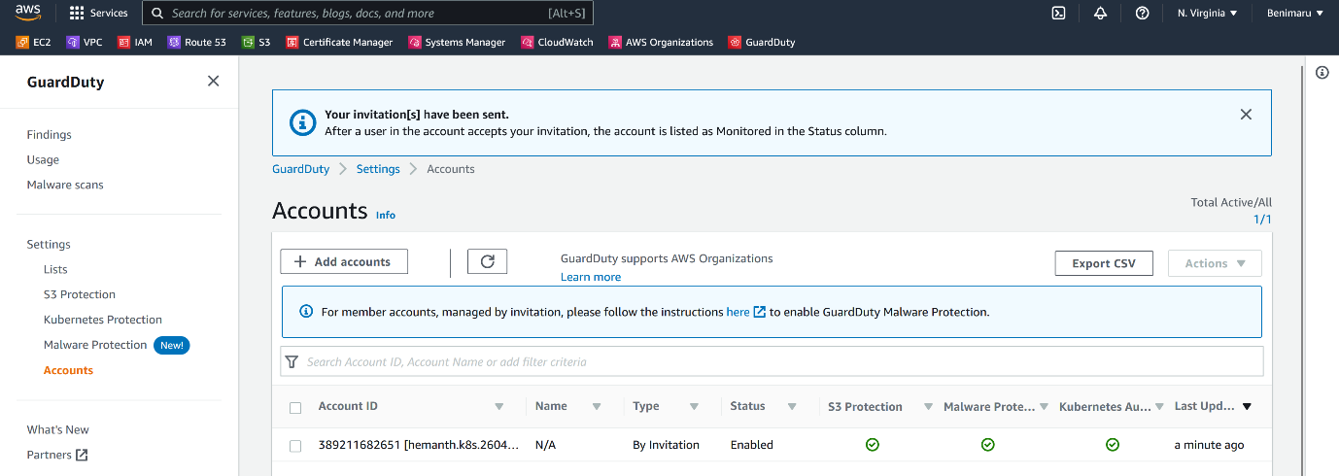

--- **note** – member account accepted our request.

**Centralized dashboard**

--- **note** – click on finding to see centralized dashboard.

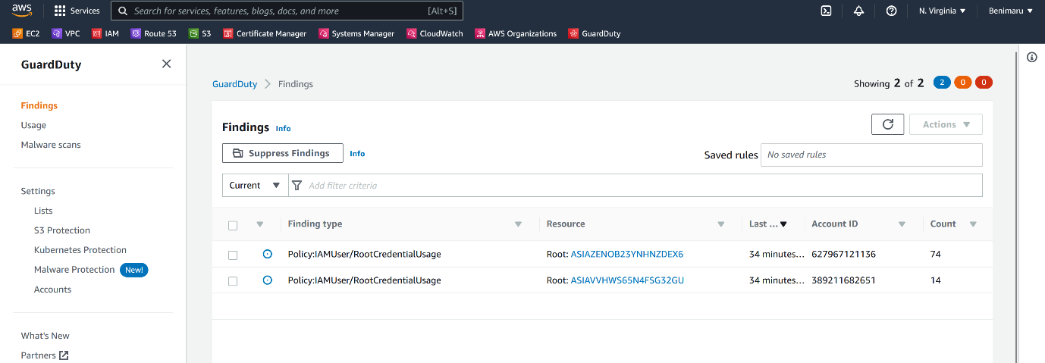

--- **note** – these 2 findings are from 2 different accounts.

**Member account**

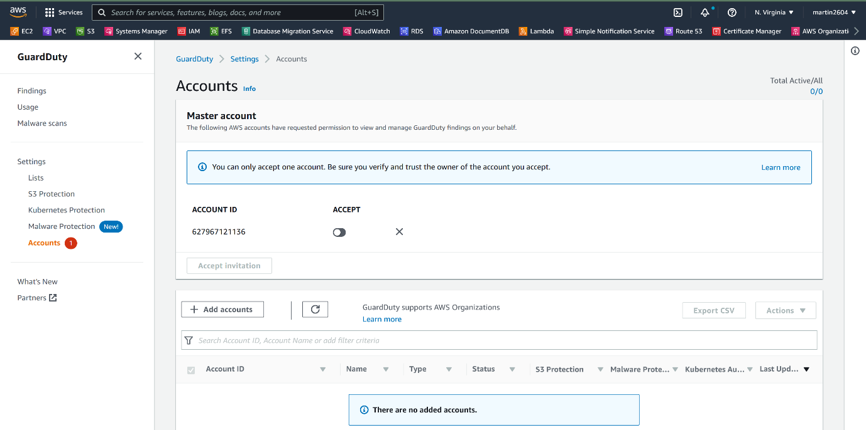

--- click on accounts.

--- click on accept to accept the invitation from master account.

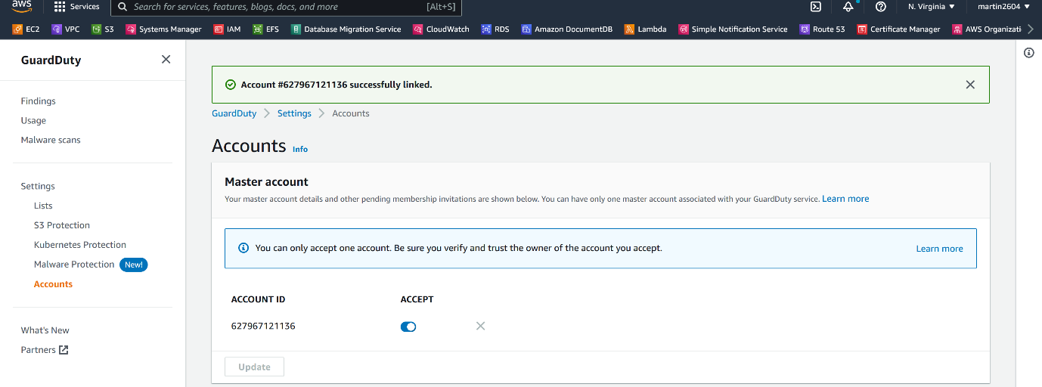

--- the invitation successfully accepted.